**AN APPRAISAL OF TOUCHLESS TOUCH SCREEN TECHNOLOGY**

**BY**

**ZACHARIAHA AIDEN YARATSADA**

**REGISTRATION NUMBER:**

**ST/CS/HND/18/009**

**A SEMINAR**

**PRESENTED TO**

**THE DEPARTMENT OF COMPUTER SCIENCE, SCHOOL OF SCIENCE AND TECHNOLOGY, FEDERAL POLYTECHNIC MUBI ADAMAWA STATE, NIGERIA.**

**FEBUARY 2021**

**TOUCHLESS TOUCH SCREEN TECHNOLOGY**

**ABSTRACT**

*Touchscreen display is ubiquitous world. Frequently touching a touchscreen display with a pointing device such as a figure can result in the gradual desensitization of the touchscreen to input and can ultimately lead to failure of the touchscreen. To avoid a simple user interface for touchless control of electrically operated equipment is being developed. Elliptic Laps control innovative technology let control the gadget like computer, MP3 players or mobile phones without touching them. A simple user interface for touchless control of electrically operated equipment unlike other system which depend on distance to sensor or sensor selection this system depends on hand or finger motion, a hand wave in a certain direction, or a flick of the hand in one area, or holding the hand.*

**INTRODUCTION**

Elliptic Labs is developing less control of the electrically operated equipment. This system depends on movements of the hand or finger, a movement of the hand in some direction. The sensor can either be placed on the screen or close to the screen. The touchscreen allows the user to interact directly with what is displayed, rather than using a mouse, touchpad, or any other intermediary device (other than a stylus, which is optional for most modern touchscreens). (Kalaiselvi and Vengateshkumar,2019)

Touchscreens are popular in devices such as game consoles, personal computers, tablet computers, electronic voting machines, point of sale systems, and smartphones. These can also be linked to computers or networks, as terminals. In the design of digital devices such as personal digital assistants (PDAs) and some e-readers, these also play a prominent role. The popularity of smartphones, tablets and lots of sorts of information devices drives the demand and acceptance for portable and functional electronics of touch screens. (Akshay,2016).

Touchscreens are often utilized in the medical and heavy industry sectors also as in cash machine machines (ATMs) and kiosks like museum displays or room automation, where keyboard and mouse systems don't allow the user to interact with the content of the display in a suitably intuitive, fast or accurate manner. Historically, a wide range of after-market system integrators and not display, chip, or motherboard manufacturers have made the touchscreen sensor and its accompanying controller-based firmware available. Worldwide, monitor manufacturers and chip manufacturers have recognized the movement towards embracing touchscreens as a highly desirable aspect of the user interface and have begun to incorporate touchscreens into their product's fundamental design. Contact less screen technology, without touching a screen, uses finger movements. It just uses a hand wave in some direction or a hand flick in one place. If the glass is broken, it cannot control the computer by simply touching a button in the touch screen panel. The goal of this less technology touch is to make life easier and more relaxed. This system requires a sensor, but on the computer the sensor is neither installed by hand nor present. The sensor can either be placed on the table or near to the screen. (Shettigar,2017).

The hardware setup is so compact that it can be installed as a mobile phone or laptop screen into a device. It recognizes a 5-feet object's location. Touch less screen technology ensures it can quickly access the machine without using a finger or touching a computer. It's also called technology "**Don't touch me**".(Shettigar ,2017).

**DEFINATION:**

Touchless Touchscreen is technology that uses gesturing as form of input. It has no need of touching screen. This technology is high-end technology, that uses hand waves and hand flicks. Objective behind building such technology is making it even more comfortable and convenient for users to use their devices. It does not need touching of screen rather system detects hand movements in front of it by making use of various sensors. ([Saxena](https://auth.geeksforgeeks.org/user/supriya_saxena/articles) ,2013)

**HOW TOUCHLESS TOUCHSCREEN WORKS**

The machine can sense 3-dimensional gestures without ever touching your fingers on the screen. Sensors are placed around the screen being used, the motion is sensed and interpreted in on-screen gestures by engaging in the line-of sight of these sensors. Using a solid state optical matrix sensor with a lens to detect hand movements, the device is based on optical pattern recognition. The sensor is then connected to a digital image processor that interprets motion patterns and outputs the results as signals for controlling fixtures, machines, equipment, or any system that can be operated by electrical signals. One can point to the screen (**up to 5 feet away**) and manipulate objects in 3D. ( Manoranjan 2018).

1. The system is capable of detecting movements in 3-dimensions without ever having to put your fingers on the screen.
2. Sensors are mounted around the screen that is being used, by interacting in the line-of-sight of these sensors the motion is detected and interpreted into on-screen movements.

**DIAGRAM SHOWING HOW IT WORKS**

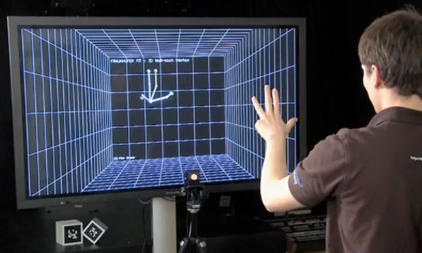

Figure 1- how touchless touch screen works. ( Manoranjan, 2018).

The Touchless technology is being used in many forms in many different places.

**EXAMPLE OF APPLICATION TOUCHLESS SCREEN TECHNOLOGY**

1. **Elliptic Labs:**

Elliptic Labs allows the user to control his or her computer without touching it, a hand wave in certain directions. It uses ultrasound so that it operates with your audio devices, not with cameras. Ideally you need 6 speakers and 8 microphones, but it could also work with the dedicated speakers on laptops and a standard microphone. The speaker will emit ultrasound that will bounce to microphones to track hand movements of a user that the Elliptic Labs software will interpret. Designed to work on the Windows 8 platform, this technology is expected to work on tablets, smartphones and even cars. Elliptic Labs is not available for consumers to buy as the company focuses on marketing it to manufacturers of original equipment (OEM).

[**Elliptic Labs**](http://www.ellipticlabs.com/) allows you to *operate your computer without touching it* with the Windows 8 Gesture Suite.

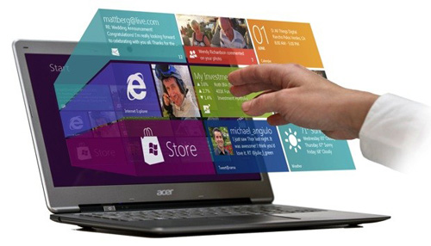

Figure 2- touchless gesture suit (Akshay,2016)

1. **Eyesight:**

Eyesight is a gesture system that monitors the gestures of ones fingers and helps them to navigate through the device by pointing at them. EyeSight's basic requirement to work is to have a standard 2D webcam (even the built-in ones work) and the app, screen doesn't even need to be one with touch technology. To navigate, just move a finger to move the cursor, push the finger to press (like pushing a button). Eyesight not only deals with computers and laptops, it also works with many other apps, such as smartphones, TVs and much more.

[**Eyesight**](http://www.eyesight-tech.com/) is a gesture technology which allows you to navigate through your devices by just pointing at it.

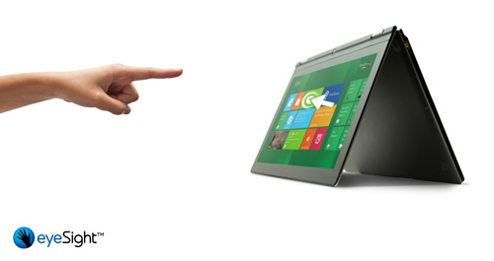

Figure 3-EyeSight Gesture of hand moving (Akshay,2016)

1. **Myoelectric Armband**

[Myoelectric armband](https://getmyo.com/) or MYO armband is a gadget that allows you to control your other bluetooth enabled devices using your finger or your hands.

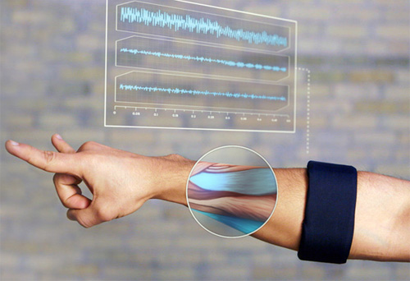

Figure 4- **Myoelectric Armband**(Akshay,2016)

1. **Airwriting**

Airwriting is a technology that enables you to write text messages or write emails in the air. Sensors attached to glove monitor hand movements, a computer system captures and converts specific signals into texts that can then produce emails and text messages or any other form.

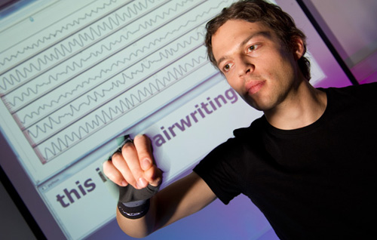

Figure 5- **Airwriting** (Akshay,2016)

1. **Leap Motion:**

Leap Motion is a motion sensor system that, with its infrared LEDs and cameras, recognizes the user's fingers. Since it works by knowing just the fingertips, nothing registers when fingers move over it to type on the keyboard.

[Leap Motion](https://www.leapmotion.com/) is a motion sensor device that recognizes the user’s fingers with its infrared LEDs and cameras

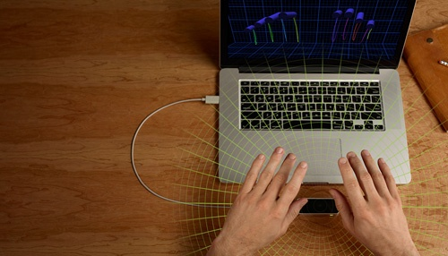

Figure 6: **Leap Motion** (Akshay,2016)

**TOUCH LESS MONITOR:**

1. The monitor, based on technology from TouchKo was recently demonstrated by White Electronic Designs and Tactyl Services at the CeBIT show.
2. The technology detects motion in 3D and requires no special worn-sensors for operation.

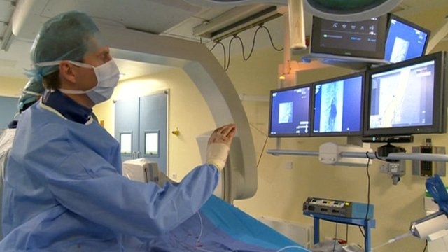

Figure 7: Doctor using Touchless Touchsreen (Akshay,2016)

**ADVANTAGE OF TOUCHLESS TOUCHSCREEN TECHNOLOGY**

1. The device last for a longer time. E.g broken screen.
2. Simple and easy to use.
3. Good for people with physical must be disabilities.
4. Since the screen is touchless, a transparent image will be clear because command are accept using such as verbal or hand gesture.
5. It doesn’t need driver.
6. No screen desensitization.
7. Good for people with physical disabilities.

**DISADVANTAGE OF TOUCHLEES TOUCHSCREEN TECHNOLOGY**

1. A good environment is required
2. The contact of the public must be monitored.
3. There is a very high initial cost.
4. Uses in a sophisticated environment.

**CONCLUSION**

Today's thoughts are again around the user interface. Day-in and day-out efforts are being made to improve the technology. Touchless screen technology can be used effectively in computers, cell phones, webcams, laptops and any other electronic devices. The body may be transformed into a virtual mouse, virtual keyboard or converted into an input device after the few years.

**REFERENCE**

Aditidhol, S, Goudar, S. and Shettigar, A. (*2017*). Touchless TouchScreen User Interface”” *International Journal of Technical Research and Applications* e-ISSN: 2320-8163 www.ijtra.com Special, Issue 43 PP. 59-63.K. Elissa,“Title of paper if known,” published.

Akshay, V. (2016). Touchless touchscreen technology slideshare.net Engineering published on Aug 29, 2016 Access February 9th 2021http://touchless touchscreen technology slideshare.net

Raghavandara, M. V. *(2010)*. Touchless touchscreen technology scientific research. *International journal of current engineering and scientific research* (IJCESR ). pdfISSN (PRINT):2393-8374, (ONLINE): 2394-0697, VOLUME-4, ISSUE-11, 2017. Retrieved February 2021.

<http://troindia.in/journal/ijcesr/vol4iss11part4/48-> 52

Kalaiselvi, N. and Vengateshkumar, S. (2019). Touchles s touchscreen technology scientific research. *International Journal of recent scientific research* Retrieved Access February 3th  2021,<http://dx.doi.org/10.24327/ijrsr.2019.1010.4086> http://recentscientific.com/touch-less-touch-screen

Manoranjan, K1. & Surendran, J. k2. (2018). Touchless Touchscreen Technology*” journal of International Research Journal of Engineering and technology (*IRJET),: 04-Apr-2018.M. Young, The technical Writer’s Handbook. Mill Valley, CA: University Science, 1989.

[Supriya, S](https://auth.geeksforgeeks.org/user/supriya_saxena/articles). Nilofar, E. & Chanda, C. (2013). Touchless Touchscreen Technology 5th Floor, A-118, Sector-136, Noida, Uttar Pradesh-201305) Access Febuary 9th 2021 <http://www.etre.com/blog/2008/02/elliptic_labs_touchless_user_interface>